ALICE JONES  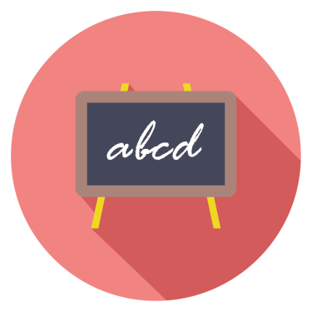  TEACHER  123, The Dairy  Swinton  Derby DE1 234  (01332) 123456  alice.jones@aol.com  “ Alice has proved herself highly capable of promoting partnerships and collaborative working, and of working as a role model for both students and staff.” ~ JANET LONG, HEAD SCHOOLSRUS  “ Alice is an inspiring and dedicated teacher of English who has the ability to push the boundaries of Learning and Teaching.” ~ BOB BROWN, HEAD, SUPASCHOOL |  | OBJECTIVE  I am a talented, dynamic and an ambitious English teacher, who can ensure good progress for all pupils. I can inspire and facilitate high quality learning through engaging and effective teaching techniques. I am looking for a position teaching English at KS3/KS4.  KEY SKILLS  - Qualified Teacher Status (QTS / QTLS). - Previous experience delivering English lessons to Key stage 3 and Key stage 4 students. - Ability to plan, deliver and assess lessons that ensure students are learning at their full potential. - Exceptional verbal and written communication, professional yet friendly body language, and the ability to really listen. - Good motivational skills. - Excellent behaviour management skills and the ability to keep students engaged and on task. - Confident in attending school meetings and parents evenings as and when required. - Ability to create strong working relationships with both students and colleagues. - Able to adapt communication style to the needs of different students depending on age, culture, ability & learning style.  WORK EXPERIENCE  English Teacher  SchoolsRUs ~ 2015 – 2018  This role required me to be a dynamic, inspirational and enthusiastic classroom practitioner with high expectations of my own classroom. I was fully committed to learning, high quality teaching and raising standards of all students, passionate about my subject; and able to inspire and motivate students and staff. At all times I was committed to ensuring all students reach their potential.  English Teacher  Supaschool ~ 2011– 2015  This role required me to operate within a dynamic and forward thinking team who are focused on developing exciting and engaging learning experiences for students across the 11-19 age range. In this role I was able to recognise opportunities and face challenges, whilst maintaining my sense of humour and care for young people. At all times I showed high levels of enthusiasm, ambition, energy, resilience and determination.  Trainee Teacher  Very Big School ~ 2009 - 2011  In this role, I developed an appreciation for the place of English in the development of young people and of the place of English within the wider curriculum. I maintained excellent relationships with students and parents, and demonstrated a willingness to explore innovative and dynamic methods for teaching and learning.  QUALIFICATIONS  Qualified Teacher Status (QTS)  BA English (Upper Second Class Honours)  Super University Limited ~ 2007-2009  A Levels  Super College Limited ~ 2005-2007  English (A), Maths (A), Biology (A), Media (C)  GCSEs  Super School Limited ~ 2001-2005  9 GCSEs grade C and above including English (A) and Maths (A)  INTERESTS  Knitting, Reading, Cooking, Jewellery Making, Photography, Scrapbooking.

Images used in this file are subject to copyright and may not be distributed. This CV template is subject to copyright. You may use it for personal use only.
Fonts required:
Open Sans Light - https://fonts.google.com/specimen/Open+Sans
Acme (this is used for the quotation marks) – https://www.cvtemplatemaster.com/fonts/Acme____.ttf
©CVtemplatemaster.com

