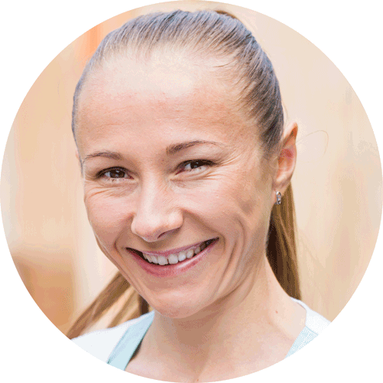
Claire Jones | RNA
123, Broadway, Lincoln LN1 234 | 01332 123456 | clairejones@hotmail.com
 Personal statemeNT 
I am an NMC registered nurse (adult nursing) with an excellent clinical track record. I am an exceptionally well organised individual with administration experience and excellent interpersonal and people management skills.
I understand the importance of taking a person-centred approach and in every aspect of my nursing, I ensure my patients are respected, involved and feel in control. I have previous experience with complex care, high dependency patients and spinal cord patients. I have been trained on CQC standards and I ensure the care I deliver is fully compliant.
 work history 
Clinical Nurse, Care2U Limited | June 2014 - date
In my current role, I provide clinical advice, training and support to all levels of staff. Through monitoring and training I ensure staff are competent to carry out their role safely and effectively, possessing the necessary knowledge to be able to work efficiently and independently within the team.
As a member of the leadership team I am responsible for ensuring the entire facility operates effectively and that the business delivers the very best quality care. I regularly carry out risk assessments, care reviews and audits, and I verify MAR charts. This is a fast paced, professional and team-orientated working environment and therefore, taking a hands-on can-do attitude is key to my success in this role.
Regional Clinical Development Nurse, Care4Me Limited | Jan 2004 – May 2014
In this role I lead, supported and worked to continuously improve the clinical governance and quality of care for residents across eight care homes. I supported the performance of each home, ensuring it operated to the highest clinical standards. Each month, I reviewed the clinical governance database and KPIs of the individual homes, analysing the results and identifying appropriate strategies to make sure all regulations are met – whilst ensuring the organisation continually improved the care it delivered.
https://www.cvtemplatemaster.com/cv-template/

 work history (cont.) 
Nurse, Future Care Limited | Jan 1991 – Dec 2003
In this role I was responsible for ensuring the highest standards of person-centred care were delivered at all times by undertaking accurate assessment and planning of care, delivery and ongoing evaluation of the care plans. I carried out typical nursing tasks that included the distribution of medication, dressings, catheterisation, tube feeding and management of chronic medical conditions. In addition I provided support and guidance to all staff including training of new members. I also liaised with both health and social care professionals and family members involved in the wellbeing of individual residents to maintain a holistic approach to their care.
 education 
Universities R US | Sept 1988 – June 1990
Bachelor's degree in Nursing (Upper Second Class Honours) specialising in Adult Nursing
College2U | Sept 1986 – June 1988
A Level Biology (A), Chemistry (B) and English Language (C)
Secondary2U | Sept 1980 – June 1986
Nine GCSEs (including mathematics, English language and Biology) at Grade C or above
 interests 
When I am not at work, I enjoy going to the gym and hiking. I also take part in several half marathons each year for charity. I am involved with my local community group, ‘Nottingham Elderly’, where I lead a small team of volunteers in ensuring lone elderly people are visited regularly.
 references 
Available on request.

© CVTemplateMaster.com

This CV template may be used for personal use ONLY. Please see our terms of use. For questions, contact us: contact@cvtemplatemaster.com

The images and fonts used in this file are used under licence and must not be reproduced, except in connection with the use of this CV template for your own personal use.
Fonts required:
Open Sans Light - https://fonts.google.com/specimen/Open+Sans
Open Sans – as above
Wingdings - http://www.911fonts.com/font/download_WingdingsRegular_10948.htm
Content credits:
Some of the example content within this CV was adapted from:
Indeed.com
Indeed.com (2)
Indeed.com (3)
Download page:
The download page for this CV is : https://www.cvtemplatemaster.com/cv-template/nursing-cv/

