Jane Green | Brand Manager
I am an experienced Brand Manager ready to take ownership of your brand and further develop your customer offering. I have a commercial eye for direction aimed at the younger end of the market with proven experience of brand development. With a strong can-do attitude and a head for everything from figures and strategy to sales and social media, I’m ready to drive your clothing brand forward.
 | (01949) 123456 |  |  |  | jane.green@aol.com
Work history  Brand Manager  Fashion2U Ltd, 2015 - date  Working with in house designer to keep brand in line with company guidelines.  Full management of critical path, trading and budgets.  Planning and execution of all trade shows increasing brand awareness within the industry.  Analysing sales, creating strategies to improve sales and beat targets.  Working with design team to guide and direct to ensure correct product mix delivered at the right time.  Brand Manager  FashionsRUS Ltd, 2011 - 2015  Full involvement in setting the business strategy to drive the business across international platforms and markets.  Accountable for correct options, price points and category mix.  Identifying the brand's position with the core marketplace and embedding improvements.  Managing and developing accounts with high street retailers and e-tailers.  Developing the brand’s vision and business deliverables into engaging marketing and merchandising.  Liaising with External PR Company.  Provide training and technical support to both internal and external stakeholders. |  | 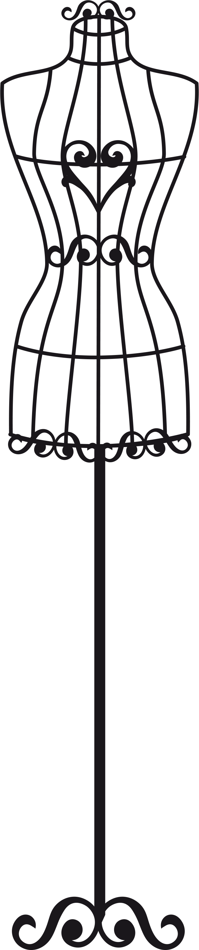 |  |  |  | Work history (cont.)  Assistant Brand Manager  Clothes2U Ltd, 2009 - 2011  Developing the brand’s vision and business deliverables into engaging marketing and merchandising strategies.  Managing existing client accounts and ensuring that key relationships remain strong and tenable.  Junior Brand Executive  Supafashion, 2015 - date  Managing all the social media channels of the business.  Achieving brand targets on commercial performance, customer engagement and ROI.  Education  BA (Hons) Fashion Design (2:1)  De Montfort University  2009 - 2011  4 A Levels (A, A, B, B)  De Montfort University  2006 – 2008  Key skills  Previous Experience managing brands within hi fashion womenswear.  Ability to be confident dealing with directors and buyers and presenting all levels.  Confident with interpreting figures and setting budgets.
References
Alison Lewis, CEO - Fashion2U Ltd  Alison.lewis@fashion2u.com |  |  |  | James Sprogson, CEO - FashionsRUS Ltd  James.sprogson@fashionsrus.com
This CV template is subject to copyright. You may use it for personal use only.
Fonts required:
Open Sans Light - https://fonts.google.com/specimen/Open+Sans
©CVtemplatemaster.com
The images used in this file are subject to copyright and are used under licence. You may not distribute them and may only use them as part of this CV template for personal use.
Download page : https://www.cvtemplatemaster.com/cv-template/free-fashion-word-cv-template/

